Title: News Recommendation System.

Name: Vipul Manish Rana

Student Id: 1124978

Technologies Used: Django, Python, Jupyter Notebook

Abstract: News Recommendation System is built as a Data Science project. The main aim for the project is to recommend news to the users based on the news they are currently reading. The front end of the system is working on Django. And the back end is been written in python. The dataset initially used for the project is been used from the Kaggle which is a open source dataset and is available to use.

Working:

The working of the data science project can be categorized in phases.

1. Data Analyzing: The very first step if the project was to select the dataset and to analyse the dataset we are working on. The reason for the particular dataset used in the project is since it had a column which contains the summary of the news. Which was a very big advantage which would be helpful in the recommendation. The other dataset I encountered was
2. Data Wrangling: The next step performed in the project is to perform data wrangling. The process included cleaning the data i.e., removing unwanted features, removing unwanted rows for example remove the rows with empty data. Then one of the action performed was to convert all the test in the lower case so we can try and compare the keywords that we created with all the other news. Which will be further helpful. Also performed the operations of removing all the stopwords those are unneccessary ( for example: a, the, this, that, but. If, etc).
3. Data Modelling: The functions were created where we were trying to compare the keywords in the news selected by the user. With the keywords of the other news. And we created a matrix using tf-idfvectorizer feature available in the python which is one of the basic algorithm used for recommendations system. We also filter the the selected news from all the recommendations that we don’t need or not much relatable since the similarity score is less. So In the project we are displaying the top 5 news with highest similarity score.
4. Displaying result: The front-end of the system is a website build using Django. The user is displayed the table which shows the news id, link, title and the data. At current stage the users selected the news he want’s to read and enters the news id in the search window. The id is given as a input in function “sub-news” in the python which takes the id and performs the function call and display the list of the result on the next page. If user enters nothing and press enter. It will display a message to select the news id.

The flow chart will help to display the flow of the system working:

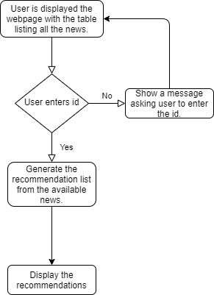

The steps to run the recommendation system:

1. Install Django in you system

pip install django

Can check the version the of the Django using the following command:

django-admin –version

1. Next step is to create a project in Django. This step will create a structure for the website with the basic required files.

Navigate to the location you want to create the project and write the following command:

django-admin startproject projectname

1. You can go ahead and use pycharm to create files or can do it manually and write codes in them.
2. To run the dango project you need to go to the root folder of the project which has manage.py file in it and enter the following command:

python manage.py runserver

1. This command is running successfully, it will display a https link for the website. Copy the link and paste in any browser and you can see the webpage you created.

The Screenshots of the project execution.

